

Enhanced Uppwise Monitoring & Security Solutions: Azure

White Paper

 UW-ITMOSEC-01

 12/04/24

 **Raunak Sharma**

[**Support@uppwise.com**](mailto:Support@uppwise.com)

 [www.uppwise.com](http://www.uppwise.com)



Mauro Contini

**Ravi P Gupta**

**Luca Paciolla**

**Contents**

1. ABSTRACT 5

2. Introduction 5

2.1 Overview of the Problem or Topic Being Addressed 5

2.2 Purpose of the White Paper 5

2.3 Importance of the Topic 6

2.4 Outline of What Will Be Covered 6

3. Background/Problem Statement 6

3.1 Detailed Explanation of the Problem or Issue Being Addressed 6

3.2 Relevant Background Information to Provide Context 6

3.3 Data or Statistics Supporting the Existence or Significance of the Problem 7

4. Implemented Solution & Approach 9

4.1 Description of the conducted Solution or Approach 9

4.1.1 Unified Monitoring and Security Platform: 9

4.1.2 Advanced Threat Detection and Response: 9

4.1.3 Continuous Compliance Monitoring: 9

4.1.4 Scalable and Flexible Architecture: 9

4.2 Explanation of How it Addresses the Identified Problem 9

4.3 Unique Features or Advantages of the Implemented Solution 10

5. Challenges and Risks 11

5.1 Identification of potential challenges or obstacles to implementation: 11

5.1.1 Complexity of Integration: 11

5.1.2 Skills Gap: 11

5.1.3 Compliance Requirements: 11

5.2 Assessment of associated risks: 11

5.2.1 Data Breaches: 11

5.2.2 Cyber Attacks: 11

5.2.3 Compliance Violations: 11

5.3 Mitigation strategies: 11

5.3.1 Comprehensive Security Planning and Implementation: 11

5.3.2 Continuous Monitoring and Threat Detection: 12

5.3.3 Employee Training and Awareness: 12

5.3.4 Internal Security Operations Center (SOC): 13

6. Integrating Monitoring and Security Proposed Solution on Uppwise Azure Infrastructure 13

6.1 Importance of Integrating Monitoring and Security: 13

6.2 Microsoft Defender for Cloud and Azure Monitor Integration: 13

6.3 Azure Policy and Governance: 13

7. Comprehensive Architectural Diagram: Implemented Integrated Monitoring and Security Solution 14

8. Exploring Azure Monitoring Services: Components Overview 15

8.1 Azure Monitor Overview: 15

8.1.1 Azure Monitor Metrics: 15

8.1.2 Azure Monitor Logs: 15

8.1.3 Azure Application Insights: 15

8.1.4 Azure Log Analytics: 15

8.1.5 Azure Network Watcher: 15

8.1.6 Azure Advisor: 16

8.2 Best Practices for Monitoring in Azure: 16

9. Exploring Azure Security Services: Components Overview 16

9.1 Microsoft Defender for Cloud Overview: 16

9.2 Azure Key Vault: 16

9.3 Azure Security Features (Firewall, DDoS Protection, etc.): 17

9.4 Azure Active Directory (Identity and Access Management): 17

9.5 Azure Policy: 17

9.6 Azure Resource Manager Security: 17

9.7 Best Practices for Security in Azure: 17

10. Microsoft Defender Benchmarks & Security Score 17

11. Case Studies and Examples 17

11.1 Case 1: Company- Maersk Line 17

11.1.1 Scenario: 17

11.1.2 Outcome: 18

11.1.3 Lesson Learned: 18

11.2 Case 2: Company- Siemens AG 18

11.2.1 Scenario: 18

11.2.2 Outcome: 18

11.2.3 Lessons Learned: 18

11.3 Lessons learned and best practices from case studies: 19

11.3.1 Lesson 1: Proactive Threat Management: 19

11.3.2 Lesson 2: Compliance and Risk Management: 19

11.3.3 Lesson 3: Collaboration and Integration: 19

12. Future Trends and Considerations 19

12.1 Emerging Technologies and Trends in Azure Monitoring and Security: 19

12.1.1 Artificial Intelligence and Machine Learning: 19

12.1.2 Cloud-Native Security Solutions: 19

12.1.3 Extended Detection and Response (XDR): 20

12.2 Predictions for the Future of Monitoring and Security in Azure: 20

12.2.1 Convergence of Monitoring and Security: 20

12.2.2 Shift towards Cloud-Native Security Architectures: 20

12.2.3 Focus on Threat Intelligence and Threat Hunting: 20

12.2.4 Enhanced Compliance and Governance: 20

12.3 Recommendations for Staying Ahead of Evolving Threats: 20

12.3.1 Continuous Education and Training: 20

12.3.2 Collaboration and Information Sharing: 20

12.3.3 Adopt a Risk-Based Approach: 20

12.3.4 Implement Defense-in-Depth Strategies: 21

12.3.5 Stay Agile and Adaptive: 21

13 Conclusion: 21

13.1 Summary of Key Points: 21

13.2 Importance of Continuous Monitoring and Security in Azure: 21

13.3 Encouragement for Further Exploration and Implementation of Azure Monitoring and Security Services: 22

14 References and Citations: Sources Utilized in the Whitepaper 22

15. RFI FAQs: Common Queries Addressed for Information Gathering 22

# ABSTRACT

The white paper "Enhanced Uppwise Monitoring and Security Solutions: Azure" delves into the vital aspects of securing and monitoring Uppwise's cloud environments on Azure.

Emphasizing the growing significance of robust monitoring and security measures, it meticulously examines Azure's tailored services and tools designed for this purpose.

Discussing the challenges inherent in maintaining the integrity and resilience of Azure infrastructures, the paper proposes comprehensive strategies for risk mitigation and defense reinforcement.

It underscores the pivotal role of advanced Azure monitoring and security solutions, offering practical insights, case studies, and best practices to empower organizations in safeguarding their cloud environments.

Through these insights, readers gain valuable knowledge on optimizing Azure environments for enhanced visibility, resilience, and compliance, ultimately ensuring the protection of critical assets and the continuity of business operations in the digital age.

# Introduction

In today's digital landscape, the migration to cloud computing, particularly within Azure environments, has become pervasive among organizations seeking scalability, flexibility, and cost-effectiveness. However, this transition presents a host of challenges, particularly in the realms of monitoring and security. The white paper "Enhancing Azure Monitoring and Security Solutions in UPPWISE" aims to delve into these challenges and propose effective strategies for addressing them.

## 2.1 Overview of the Problem or Topic Being Addressed

As UPPWISE embraces Azure for its infrastructure needs, it encounters complexities in ensuring its cloud environments' robust monitoring and security. The dynamic nature of Azure's infrastructure and the ever-evolving threat landscape pose significant challenges. Moreover, compliance requirements add another layer of complexity, necessitating comprehensive solutions tailored to Azure's unique architecture.

## 2.2 Purpose of the White Paper

The primary purpose of this white paper is to provide our organization & stakeholders with a comprehensive understanding of the challenges involved in monitoring and securing Azure environments. By elucidating these challenges and offering practical insights and solutions, the white paper aims to empower our organization to enhance its Azure monitoring and security posture effectively.

## 2.3 Importance of the Topic

The importance of this topic cannot be overstated, considering the critical role that Azure plays in our modern business operations. Inadequate monitoring and security measures can expose organizations to various risks, including data breaches, service interruptions, and regulatory penalties. By prioritizing Azure monitoring and security, we can mitigate these risks, safeguard our assets, and maintain the trust of our stakeholders.

## 2.4 Outline of What Will Be Covered

This white paper will comprehensively cover various aspects related to enhancing Azure monitoring and security solutions. It will delve into the challenges we face in monitoring and securing Azure environments, explore best practices for addressing these challenges, and highlight the role of advanced Azure monitoring and security tools and techniques. Additionally, the paper will provide practical insights, case studies, and actionable recommendations to help organizations to optimize the Azure monitoring and security posture effectively. Along with highly sophisticated Architectural visual diagrams to understand the flow and address the solutions and its complexities.

# Background/Problem Statement

The proliferation of cloud computing, particularly within Azure environments, has revolutionized the way our organizations operate and scale their infrastructure. However, this shift has also introduced a myriad of challenges, foremost among them being the need for robust monitoring and security solutions.

## 3.1 Detailed Explanation of the Problem or Issue Being Addressed

Ensuring data and services' integrity, confidentiality, and availability within Azure environments is paramount for our organization. However, the dynamic nature of Azure's infrastructure, characterized by its scalability, multi-tenancy, and diverse array of services, poses significant challenges for effective monitoring and security. Traditional approaches to monitoring and security are often inadequate to address the unique requirements of Azure environments, leading to gaps in visibility, compliance, and threat detection.

Moreover, the evolving threat landscape further complicates matters, with cyberattacks becoming increasingly sophisticated and frequent. From ransomware attacks to data breaches, our organization can face a plethora of threats that can disrupt operations, compromise sensitive information, and tarnish its reputation.

## 3.2 Relevant Background Information to Provide Context

To understand the magnitude of the problem, it's essential to consider the rapid adoption of Azure and cloud computing in general. Organizations across industries are leveraging Azure's scalability, flexibility, and cost-effectiveness to drive innovation and accelerate digital transformation initiatives. However, this widespread adoption also means that a vast amount of sensitive data and critical workloads are now hosted in Azure environments, making them lucrative targets for cybercriminals.

Furthermore, regulatory requirements, such as ISO27K, GDPR, HIPAA, and PCI DSS, impose stringent data protection and compliance mandates, adding another layer of complexity to Azure monitoring and security efforts.

## 3.3 Data or Statistics Supporting the Existence or Significance of the Problem

Recent data and statistics underscore the pressing need for enhanced Azure monitoring and security solutions. According to the Microsoft Security Intelligence Report, cyberattacks targeting cloud-based environments have increased by 300% in recent years, highlighting the growing threat landscape. Additionally, studies show that organizations often struggle with identifying and remediating security incidents in their Azure environments, with the average time to detect and respond to a breach exceeding months in some cases. These statistics emphasize the critical importance of prioritizing Azure monitoring and security to mitigate risks and protect valuable assets.

**Reference Security Data/Insights from Agencies and Companies**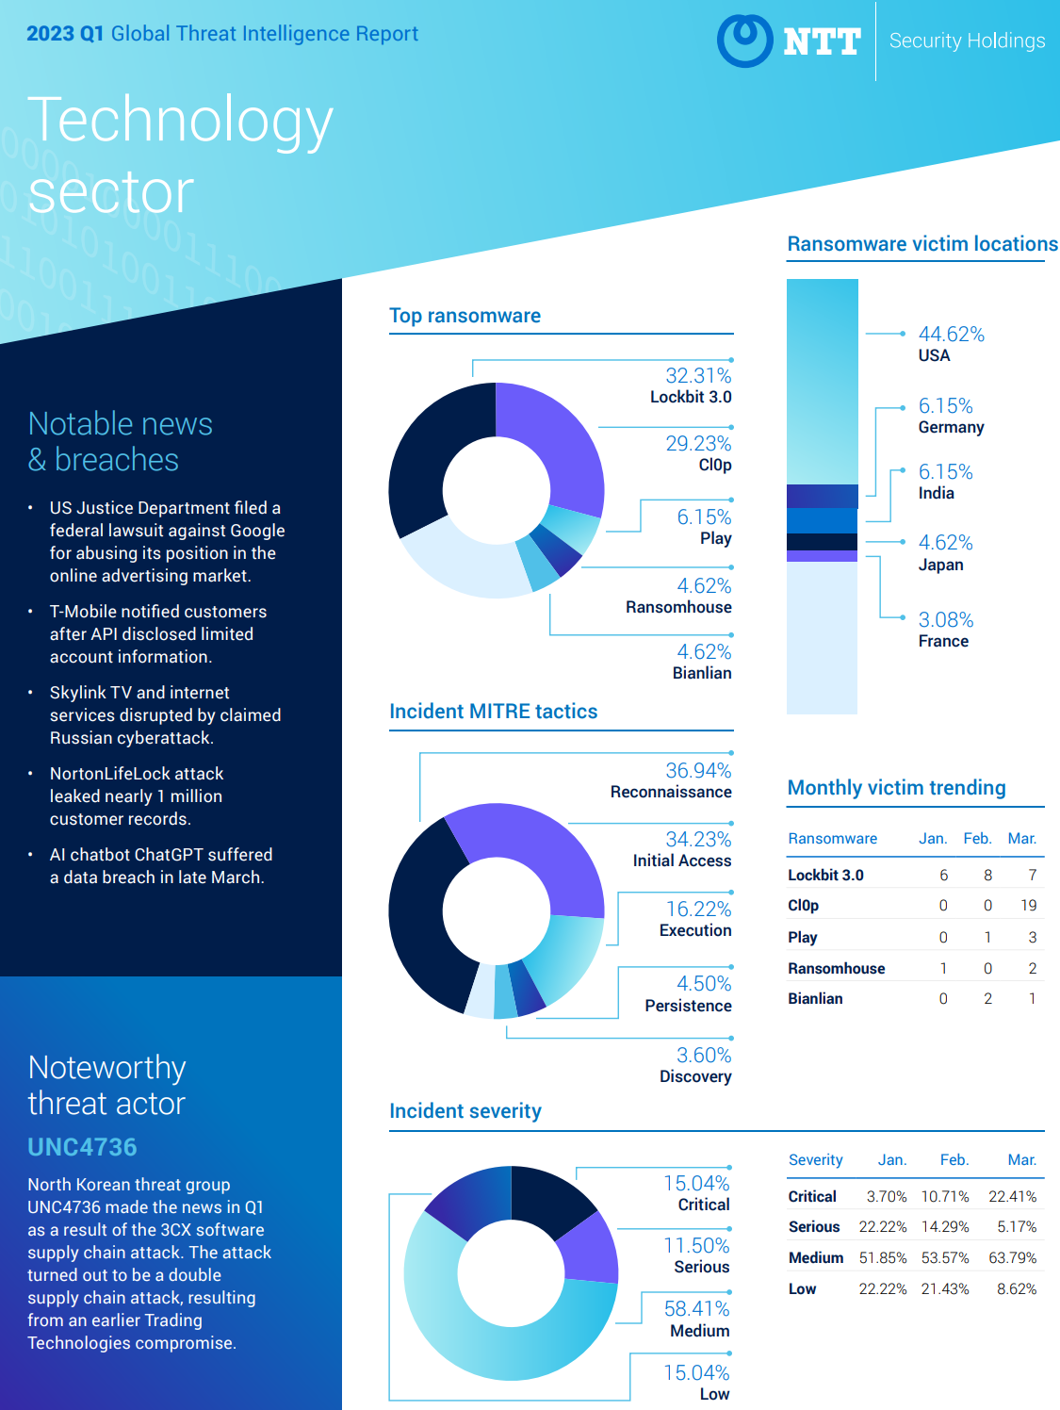

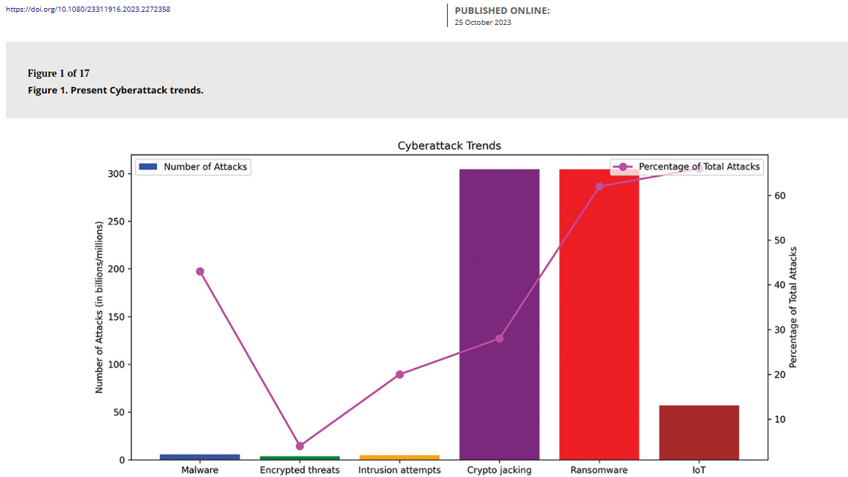

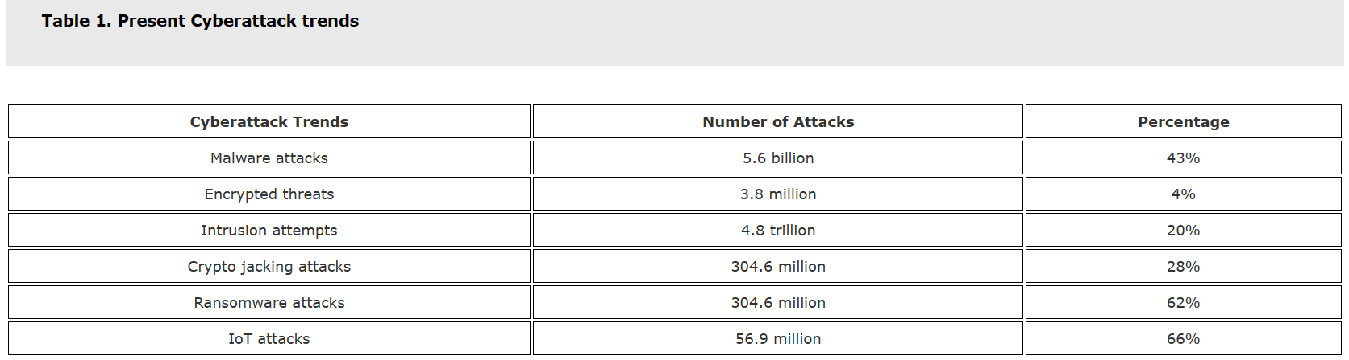

# Implemented Solution & Approach

To address the challenges and gaps identified in the previous state of Azure monitoring and security, we proposed and conducted a comprehensive solution that leverages a combination of native Azure tools, and best practices in cloud security and monitoring.

## 4.1 Description of the conducted Solution or Approach

Our approach to the solution encompasses the following key components:

### 4.1.1 Unified Monitoring and Security Platform:

Implement a unified monitoring and security platform that integrates native Azure tools such as Azure Monitor, Azure Defender for the cloud, dashboards, custom logs analytics, etc. This platform provides centralized visibility, control, and analysis of Azure resources, enabling organizations to detect and respond to security threats in real-time.

### 4.1.2 Advanced Threat Detection and Response:

Deploy advanced threat detection and response capabilities Defender for cloud and customs notifications and alerts. These capabilities enable proactive threat hunting, anomaly detection, and automated response to security incidents, minimizing the impact of cyberattacks and reducing the time to detect and respond to threats.

### 4.1.3 Continuous Compliance Monitoring:

Implement continuous compliance monitoring to ensure adherence to regulatory requirements and industry standards. This includes automated compliance checks, policy enforcement, and remediation workflows to maintain compliance posture and mitigate compliance-related risks.

### 4.1.4 Scalable and Flexible Architecture:

Design a scalable and flexible architecture that can accommodate the dynamic nature of Azure environments. This includes scalable data ingestion, processing, and storage capabilities to handle large volumes of telemetry data generated by Azure resources.

## 4.2 Explanation of How it Addresses the Identified Problem

Our solution addresses the identified challenges and gaps in the previous state of Azure monitoring and security by:

* Providing centralized visibility and control over Azure resources, enabling organization to monitor, analyze, and respond to security threats more effectively.
* Leveraging advanced threat detection and response capabilities to detect and mitigate security incidents in real time, reducing the risk of data breaches and service interruptions.
* Ensuring continuous compliance monitoring to maintain regulatory compliance and mitigate compliance-related risks.
* Offering a scalable and flexible architecture that can scale with the growth of Azure environments and adapt to evolving security threats and compliance requirements.

## 4.3 Unique Features or Advantages of the Implemented Solution

Our solution offers several unique features and advantages, including:

**Integration with native Azure tools and third-party solutions:**

Our solution seamlessly integrates with native Azure monitoring and security tools and third-party solutions, providing organizations with a comprehensive and unified platform for monitoring and security. This integration ensures that organizations have access to a wide range of monitoring and security capabilities within a single interface, streamlining operations and improving efficiency.

**Advanced threat detection and response capabilities:**

Leveraging automation and Microsoft Defender for Cloud, our solution delivers advanced threat detection and response capabilities. Our solution enables proactive threat hunting and automated incident response by continuously monitoring Azure environments and analyzing telemetry data. This proactive approach helps our organization to stay ahead of emerging threats and minimize the impact of security incidents.

**Continuous compliance monitoring:**

Our solution includes built-in features for continuous compliance monitoring, ensuring adherence to regulatory requirements and industry standards. By automatically scanning Azure resources for compliance violations and generating compliance reports, our solution helps organizations reduce the risk of compliance-related penalties and fines. Customizable compliance policies allow organizations to tailor monitoring efforts to specific regulatory requirements, ensuring comprehensive coverage.

**Scalable and flexible architecture:**

Built on a scalable and flexible architecture, our solution can accommodate the dynamic nature of Azure environments. Whether organizations are scaling up their Azure footprint or adapting to changing business needs, our solution provides the agility and scalability required to meet evolving demands. This flexibility enables organizations to optimize resource utilization, minimize costs, and maintain security posture across their Azure environments.

# Challenges and Risks

## 5.1 Identification of potential challenges or obstacles to implementation:

### 5.1.1 Complexity of Integration:

Integrating multiple Azure monitoring and security services into existing IT infrastructure can be complex and time-consuming. Organizations may encounter challenges in configuring and managing these services to work seamlessly together.

### 5.1.2 Skills Gap:

Implementing and managing Azure Monitoring and Security Services requires specialized skills and expertise in cloud security, data analytics, and threat detection. Organizations may face challenges in finding and retaining qualified Security professionals.

### 5.1.3 Compliance Requirements:

Meeting regulatory compliance standards and industry regulations poses a challenge for organizations deploying Azure Monitoring and Security Services. Ensuring that security configurations & policies align with regulatory requirements can be complex & resource-intensive.

## 5.2 Assessment of associated risks:

### 5.2.1 Data Breaches:

Inadequate security measures and misconfigurations in Azure Monitoring and Security Services can expose organizations to the risk of data breaches and unauthorized access to sensitive information.

### 5.2.2 Cyber Attacks:

Threat actors may exploit vulnerabilities in Azure infrastructure or security controls to launch cyber-attacks, such as ransomware, malware, or denial-of-service (DoS) attacks, disrupting business operations and financial losses.

### 5.2.3 Compliance Violations:

Non-compliance with regulatory standards and industry regulations can result in legal penalties, fines, reputational damage, and loss of customer trust. Failure to implement effective security controls and governance practices may lead to compliance violations and regulatory scrutiny.

## 5.3 Mitigation strategies:

### 5.3.1 Comprehensive Security Planning and Implementation:

**Risk Assessment:**

Conduct a comprehensive risk assessment to identify potential security threats, vulnerabilities, and compliance gaps within the Azure environment. Prioritize risks based on their impact and likelihood of occurrence.

**Security Controls:**

Implement a layered security approach by deploying a combination of preventive, detective, and responsive security controls. Configure security policies, access controls, encryption, and monitoring mechanisms to protect Azure resources from unauthorized access, data breaches, and cyber-attacks.

**Security Baselines:**

Establish security baselines and standard configurations for Azure services and resources based on industry best practices, regulatory requirements, and organizational security policies. Regularly review and update security configurations to address emerging threats and vulnerabilities.

### 5.3.2 Continuous Monitoring and Threat Detection:

**Real-time Monitoring:**

Implement Azure Monitoring and Security Services to continuously monitor Azure resources, networks, and applications for security threats and suspicious activities. Set up alerts and notifications to promptly detect and respond to security incidents.

**Threat Intelligence:**

Leverage threat intelligence feeds and security analytics to identify emerging threats, malware signatures, and attack patterns. Stay informed about the latest cybersecurity trends, threat actors, and attack vectors to proactively defend against cyber-attacks.

**Behavioural Analytics:**

Use advanced analytics and machine learning algorithms to analyze user behavior, network traffic, and system activities for signs of anomalous behavior or security breaches. Implement user and entity behaviour analytics (UEBA) to detect insider threats and account compromise.

### Employee Training and Awareness:

**Security Awareness Training:**

Provide comprehensive cybersecurity training and awareness programs to employees, contractors, and third-party vendors. Educate them about common security risks, social engineering tactics, phishing scams, and best practices for data protection and incident response.

**Role-based Training:**

Tailor security training programs to the specific roles and responsibilities of employees within the organization. Provide specialized training for IT administrators, developers, and end-users to ensure they understand their security responsibilities and follow security policies and procedures.

**Simulated Phishing Exercises:**

Conduct simulated phishing exercises and security drills to test employees' awareness of phishing threats and their ability to recognize and report suspicious emails. Provide feedback and reinforcement to reinforce positive security behaviours and promote a culture of security awareness.

### 5.3.4 Internal Security Operations Center (SOC):

Establish an internal Security Operations Center (SOC) equipped with skilled cybersecurity professionals, dedicated tools, and technologies for monitoring, detecting, and responding to security threats within the Azure environment.

Invest in training and development programs to upskill existing IT staff in cybersecurity practices, threat detection techniques, incident response procedures, and the use of Azure Monitoring and Security Services.

# Integrating Monitoring and Security Proposed Solution on Uppwise Azure Infrastructure

## 6.1 Importance of Integrating Monitoring and Security:

The integration of monitoring and security is critical for maintaining the integrity, availability, and compliance of cloud environments like Azure. By combining monitoring tools with security solutions, organizations can detect, respond to, and mitigate security threats effectively. This integration provides comprehensive visibility into the health and security posture of Azure resources, enabling proactive threat detection, incident response, and compliance enforcement.

## 6.2 Microsoft Defender for Cloud and Azure Monitor Integration:

Azure Monitor and Microsoft Defender for Cloud (formerly Azure Security Center) seamlessly integrate to provide a unified approach to monitoring and security in Azure environments. Azure Monitor collects telemetry data from Azure resources, applications, and operating systems, while Microsoft Defender for Cloud analyzes this data to detect and respond to security threats. By integrating Azure Monitor with Microsoft Defender for Cloud, we can correlate performance metrics with security events, enabling proactive threat detection and rapid incident response.

Additionally, Defender for Cloud continuously monitors Azure environments for security threats, vulnerabilities, and suspicious activities, leveraging Azure Monitor logs and metrics for threat detection and investigation. By integrating with Azure Monitor, Defender for Cloud can analyze telemetry data in real time, detect security incidents, and automate response actions to mitigate risks effectively. This integration enables our organization to strengthen its security posture and protect Azure resources from cyber threats.

## 6.3 Azure Policy and Governance:

Azure Policy and Governance play a crucial role in integrating monitoring and security into Azure environments by enforcing compliance with organizational policies and regulatory requirements.

Azure Policy allows our organization to define and enforce policies for resource configurations, access controls, and compliance standards across the Azure environment. By integrating Azure Policy with Defender for Cloud and Azure Monitor, Uppwise can ensure that its resources adhere to security best practices and compliance standards.

This integration provides centralized visibility and control over resource configurations, access permissions, and compliance status, enabling our organization to maintain a secure and compliant Azure environment.

**In summary, integrating monitoring and security is essential for our organization to effectively detect, respond to, and mitigate security threats in Azure environments. By leveraging the integration capabilities of Azure Monitor, Azure Security Center (Defender for Cloud), and Azure Policy, Uppwise can achieve comprehensive visibility, threat detection, and compliance enforcement across their Azure resources and applications.**

# Comprehensive Architectural Diagram: Implemented Integrated Monitoring and Security Solution

A sophisticated professional architectural diagram for an integrated monitoring and security solution in UPPWISE on Azure involves illustrating the various components and their interactions.

This architectural diagram shows the integration of monitoring and security components within an Azure environment to provide comprehensive visibility, threat detection, and response capabilities.

It demonstrates how Azure Monitor, Microsoft Defender for Cloud, Azure Policy, and other Azure services work together to ensure the security, compliance, and integrity of Azure resources and applications.

Below is a high-level representation of such a solution in the visual diagram:



# Exploring Azure Monitoring Services: Components Overview

Let's break down and try to understand in brief each of these Azure monitoring services used in our solutions:

## 8.1 Azure Monitor Overview:

Azure Monitor is a comprehensive monitoring service that provides insights into the performance and health of Azure resources and applications. It collects telemetry data from various sources, including Azure resources, applications, and operating systems, and offers features such as metrics, logs, alerts, and dashboards for monitoring and troubleshooting.

### 8.1.1 Azure Monitor Metrics:

Azure Monitor Metrics enables users to monitor the performance and health of Azure resources by collecting and visualizing metrics such as CPU usage, memory utilization, and network traffic. It provides real-time insights into resource utilization and performance trends, allowing users to identify issues and optimize resource usage.

### 8.1.2 Azure Monitor Logs:

Azure Monitor Logs allows users to collect, analyze, and visualize log data from Azure resources and applications. It offers a centralized log management solution, enabling users to correlate events, detect anomalies, and troubleshoot issues across multiple sources. Azure Monitor Logs supports querying log data using the powerful Kusto Query Language (KQL).

### 8.1.3 Azure Application Insights:

Azure Application Insights is a monitoring and telemetry service for web applications. It provides insights into application performance, availability, and usage, enabling developers to identify and diagnose issues in real-time. Azure Application Insights offers features such as application performance monitoring (APM), transaction tracing, and user analytics.

### 8.1.4 Azure Log Analytics:

Azure Log Analytics is a flexible and scalable log management solution that allows users to collect, analyze, and visualize log data from various sources, including Azure resources, on-premises environments, and third-party applications. It provides advanced querying capabilities, machine learning-based analytics, and integration with other Azure services.

### 8.1.5 Azure Network Watcher:

Azure Network Watcher is a network monitoring and diagnostic service that enables users to monitor, diagnose, and troubleshoot network issues in Azure. It offers features such as network topology visualization, packet capture, flow logs, and connection troubleshooting, allowing users to optimize network performance and security.

### 8.1.6 Azure Advisor:

Azure Advisor is a personalized recommendation service that helps users optimize their Azure resources for performance, security, reliability, and cost-efficiency. It provides actionable recommendations based on best practices and Azure resource usage patterns, enabling users to improve the efficiency and effectiveness of their Azure deployments.

## 8.2 Best Practices for Monitoring in Azure:

Some best practices for monitoring in Uppwise on Azure include:

* Define clear monitoring goals and requirements based on business objectives and SLAs.
* Use a combination of Azure monitoring services to gain comprehensive insights into Azure resources and applications.
* Establish consistent monitoring and alerting policies to proactively detect and respond to issues before they impact operations.
* Leverage automation and scripting to streamline monitoring setup, configuration, and maintenance.
* Regularly review and optimize monitoring configurations based on changing business needs, resource usage patterns, and security requirements.

**By leveraging these Azure monitoring services and following best practices, our organization effectively monitors and optimizes its Azure resources and applications to ensure performance, availability, and security.**

# Exploring Azure Security Services: Components Overview

Here's a brief overview of each Azure security service:

## 9.1 Microsoft Defender for Cloud Overview:

Microsoft Defender for Cloud is a cloud-native application protection platform (CNAPP) that is made up of security measures and practices that are designed to protect cloud-based applications from various cyber threats and vulnerabilities. Defender for Cloud combines the capabilities of:

* A development security operations (DevSecOps) solution that unifies security management at the code level across multi-cloud and multiple pipeline environments.
* A cloud security posture management (CSPM) solution that surfaces actions that you can take to prevent breaches.
* A cloud workload protection platform (CWPP) with specific protections for servers, containers, storage, databases, and other workloads.

## 9.2 Azure Key Vault:

Azure Key Vault is a cloud service that securely stores and manages cryptographic keys, secrets, and certificates used by cloud applications and services. It provides centralized key management and access control for sensitive information.

## Azure Security Features (Firewall, DDoS Protection, etc.):

Azure offers built-in security features and services to protect Azure resources and applications. These include Azure Firewall, distributed denial-of-service (DDoS) protection, network security groups (NSGs), and web application firewall (WAF) to defend against various cyber threats.

## 9.4 Azure Active Directory (Identity and Access Management):

Azure Active Directory (Microsoft Entra ID) is a cloud-based identity and access management service that provides authentication, authorization, and identity protection capabilities for Azure resources and applications.

## 9.5 Azure Policy:

Azure Policy is a service that enables organizations to define, enforce, and monitor policies for resource configurations and compliance standards within their Azure environments. It helps ensure adherence to security best practices and regulatory requirements.

## 9.6 Azure Resource Manager Security:

Azure Resource Manager (ARM) is the management layer that provides access control, governance, and deployment management for Azure resources. It enables organizations to secure access, enforce policies, and manage resource lifecycles securely.

## 9.7 Best Practices for Security in Azure:

Best practices for security in Azure are guidelines and recommendations to protect Azure resources and applications from security threats and vulnerabilities. These include implementing strong identity and access management controls, securing network traffic, encrypting data, following security governance principles and Azure security benchmarks, and compliance with ISO 27K standards.

# Microsoft Defender Benchmarks & Security Score

Uppwise reviews Microsoft Defender for Cloud recommendations daily, ensuring the security level of our cloud services is consistently maintained at a high level.

Furthermore, Uppwise diligently maintains regulatory compliance and adheres to high-standard security benchmarks, including fulfillment for ISO 27001:2013

# Case Studies and Examples

Certainly! Here are some case studies and examples showcasing the use of Azure Monitoring and Security Services in leading companies:

## 11.1 Case 1: Company- Maersk Line

### 11.1.1 Scenario:

Maersk Line, the world's largest container shipping company, faced a significant cybersecurity incident in **2017 when it fell victim to the NotPetya ransomware attack**. Following this incident, Maersk Line implemented Azure Security Center and Azure Sentinel to strengthen its cybersecurity posture and protect its global network infrastructure.

### 11.1.2 Outcome:

By leveraging Azure Security Center's threat detection capabilities and Azure Sentinel's advanced analytics, Maersk Line improved its ability to detect and respond to security threats in real-time. The company enhanced its incident response processes, mitigated potential risks, and safeguarded its critical business operations against cyber threats.

### 11.1.3 Lesson Learned:

Maersk Line's experience highlights the importance of proactive threat management and the value of investing in comprehensive cybersecurity solutions, such as Azure Monitoring and Security Services, to mitigate the risk of cyber-attacks and protect business continuity.

## 11.2 Case 2: Company- Siemens AG

### 11.2.1 Scenario:

Siemens AG, a multinational conglomerate headquartered in Munich, Germany, operates in various sectors, including industry, energy, healthcare, and infrastructure. As a leading provider of industrial automation and digitalization solutions, Siemens faces the challenge of securing its digital infrastructure and protecting its critical industrial systems from cyber threats.

### 11.2.2 Outcome:

Siemens AG implemented Azure Security Center and Azure Sentinel to enhance its cybersecurity defenses and strengthen its industrial control systems' security. By leveraging Azure's advanced threat detection capabilities and security analytics, Siemens gained real-time visibility into its digital assets, network traffic, and user activities.

Siemens utilized Azure Security Center to monitor and protect its Azure cloud infrastructure, ensuring compliance with industry standards and regulatory requirements. The company implemented security policies, threat intelligence, and automated response mechanisms to detect and respond to security threats proactively.

With Azure Sentinel, Siemens established a centralized security operations center (SOC) to analyze security incidents, correlate security events, and investigate suspicious activities across its global network infrastructure. Siemens leveraged Azure Sentinel's machine learning algorithms and security analytics to detect anomalous behavior, identify potential security breaches, and mitigate security risks effectively.

### 11.2.3 Lessons Learned:

Siemens AG's experience highlights the importance of investing in comprehensive cybersecurity solutions, such as Azure Monitoring and Security Services, to protect critical industrial systems and digital assets from cyber threats. By adopting proactive security measures and leveraging advanced analytics capabilities, Siemens strengthened its security posture, mitigated risks, and safeguarded its operations against evolving cyber threats.

Siemens' success demonstrates the value of partnering with trusted cloud providers like Microsoft Azure to secure digital infrastructure, enhance threat visibility, and build resilient cybersecurity defenses. As companies increasingly rely on digital technologies and cloud services, investing in cybersecurity solutions becomes imperative to protect against cyber-attacks and maintain business continuity.

## Lessons learned and best practices from case studies:

### 11.3.1 Lesson 1: Proactive Threat Management:

Organizations should adopt a proactive approach to threat management by continuously monitoring and analyzing security data to identify and respond to potential threats before they escalate.

### 11.3.2 Lesson 2: Compliance and Risk Management:

Compliance with regulatory standards and industry regulations is critical for organizations operating in highly regulated industries such as finance, healthcare, and government. Implementing Azure Policy and Azure Security Center can help organizations enforce compliance and mitigate security risks effectively.

### 11.3.3 Lesson 3: Collaboration and Integration:

Integration between Azure Monitoring and Security Services enables organizations to streamline security operations and improve incident response capabilities. By integrating Azure Sentinel with Azure Security Center and other third-party security tools, organizations can correlate security events, automate response actions, and enhance threat detection capabilities.

**These case studies and examples illustrate how organizations across various industries leverage Azure Monitoring and Security Services to enhance security, compliance, and operational efficiency, ultimately driving business success and delivering value to customers.**

# Future Trends and Considerations

## 12.1 Emerging Technologies and Trends in Azure Monitoring and Security:

### 12.1.1 Artificial Intelligence and Machine Learning:

Azure is expected to increasingly leverage artificial intelligence (AI) and machine learning (ML) algorithms for advanced threat detection, anomaly detection, and predictive analytics in monitoring and security. AI-driven security solutions can automate threat detection, analyze large volumes of security data, and provide actionable insights to improve incident response.

### 12.1.2 Cloud-Native Security Solutions:

Azure is evolving to offer cloud-native security solutions designed specifically for securing cloud-native architectures and serverless applications. Organizations will leverage Azure-native security tools, such as Azure Security Center for Kubernetes (Azure Defender for Kubernetes), Azure Functions security features, and Azure Container Registry security scanning, to protect cloud-native workloads and microservices.

### 12.1.3 Extended Detection and Response (XDR):

Azure is expected to integrate extended detection and response (XDR) capabilities into its monitoring and security offerings, providing holistic visibility and centralized management of security incidents across hybrid and multi-cloud environments. XDR solutions will enable organizations to correlate security events, detect advanced threats, and automate response actions across Azure and non-Azure environments.

## Predictions for the Future of Monitoring and Security in Azure:

### 12.2.1 Convergence of Monitoring and Security:

Azure is moving towards integrating monitoring and security functions into unified platforms to provide comprehensive visibility and control over cloud environments. Organizations will adopt integrated monitoring and security solutions, such as Azure Sentinel, to streamline operations, improve threat detection, and enhance incident response capabilities.

### 12.2.2 Shift towards Cloud-Native Security Architectures:

As organizations migrate more workloads to the cloud, there will be a shift towards cloud-native security architectures designed to address the unique security challenges of cloud environments. Azure will continue to innovate its security offerings to provide native cloud security controls, automation capabilities, and built-in threat intelligence.

### 12.2.3 Focus on Threat Intelligence and Threat Hunting:

Azure will prioritize threat intelligence and threat hunting capabilities to proactively identify and respond to sophisticated cyber threats. Organizations will leverage Azure Sentinel and advanced threat analytics tools to collect, analyze, and correlate security data from disparate sources to detect and investigate security incidents effectively.

### 12.2.4 Enhanced Compliance and Governance:

Azure will continue to invest in compliance and governance capabilities to help organizations meet regulatory requirements and industry standards. Azure Policy, Azure Security Center, and Azure Compliance Manager will provide organizations with tools and frameworks to assess, monitor, and enforce compliance across Azure environments.

## 12.3 Recommendations for Staying Ahead of Evolving Threats:

### 12.3.1 Continuous Education and Training:

Stay informed about emerging technologies, trends, and best practices in Azure monitoring and security through continuous education and training programs. Invest in cybersecurity certifications, workshops, and industry conferences to keep skills up to date.

### 12.3.2 Collaboration and Information Sharing:

Engage with cybersecurity communities, forums, and industry associations to collaborate with peers, share insights, and learn from collective experiences. Participate in threat intelligence sharing initiatives and contribute to the community's knowledge base.

### 12.3.3 Adopt a Risk-Based Approach:

Take a risk-based approach to security by prioritizing investments and initiatives based on the organization's risk profile, threat landscape, and business priorities. Conduct regular risk assessments and security audits to identify and mitigate potential security risks.

### 12.3.4 Implement Defense-in-Depth Strategies:

Implement multiple layers of security controls, including network segmentation, access controls, encryption, and monitoring, to defend against evolving cyber threats. Adopt a defense-in-depth approach to security to create multiple barriers and layers of protection.

### 12.3.5 Stay Agile and Adaptive:

Embrace agility and adaptability in security operations to respond quickly to changing threats and attack vectors. Implement agile security practices, such as threat hunting, incident response exercises, and security automation, to improve resilience and readiness.

**By embracing emerging technologies, staying informed about future trends, and adopting proactive security strategies, organizations can stay ahead of evolving threats and effectively protect their Azure environments from cyber-attacks.**

# Conclusion:

In conclusion, the implementation of Azure monitoring and security services is essential for organizations seeking to safeguard their digital assets, mitigate risks, and ensure compliance in today's dynamic threat landscape. Throughout this document, we have explored various aspects of Azure monitoring and security, including key features, best practices, real-world examples, and future trends.

## 13.1 Summary of Key Points:

* Azure offers a comprehensive suite of monitoring and security services, including Azure Monitor, Azure Security Center, Azure Sentinel, Azure Key Vault, and Azure Active Directory, integrating them in Uppwise helps us to protect its cloud environments.
* By leveraging Azure monitoring and security services, organizations can gain real-time visibility into their Azure resources, detect, and respond to security threats, enforce compliance with regulatory requirements, and enhance operational efficiency.
* Integrating monitoring and security functions into Azure environments enables our organization to adopt a proactive approach to cybersecurity, automate security operations, and effectively manage risks across hybrid and multi-cloud environments.

## 13.2 Importance of Continuous Monitoring and Security in Azure:

Continuous monitoring and security are critical components of a robust cybersecurity strategy in Azure. With the increasing sophistication of cyber threats and the growing complexity of cloud environments, organizations must remain vigilant and proactive in identifying and mitigating security risks. Continuous monitoring enables organizations to detect security incidents in real time, respond promptly to emerging threats, and ensure the integrity, confidentiality, and availability of their Azure resources and data.

## 13.3 Encouragement for Further Exploration and Implementation of Azure Monitoring and Security Services:

As organizations continue to embrace digital transformation and cloud adoption, the need for effective monitoring and security solutions in Azure will only grow. We encourage organizations to explore and implement Azure monitoring and security services to enhance their cybersecurity posture, protect against evolving threats, and achieve their business objectives securely. By investing in Azure monitoring and security services, organizations can mitigate risks, build trust with customers and stakeholders, and drive innovation and growth in the cloud.

In conclusion, Azure monitoring and security services play a crucial role in enabling organizations to secure their Azure environments, adapt to evolving threats, and achieve business resilience in the digital age. We encourage organizations to prioritize cybersecurity and leverage Azure monitoring and security services to safeguard their digital assets and maintain a competitive edge in the cloud.

# References and Citations: Sources Utilized in the Whitepaper

1. Azure Security Center Documentation. Retrieved from [<https://docs.microsoft.com/en-us/azure/security-center/>]
2. Data shows cyber-attacks: Retrieved from [A new world of security: Microsoft’s Secure Future Initiative - Microsoft On the Issues](https://blogs.microsoft.com/on-the-issues/2023/11/02/secure-future-initiative-sfi-cybersecurity-cyberattacks/)
3. [Microsoft Digital Defense Report shares new insights on nation-state attacks | Microsoft Security Blog](https://www.microsoft.com/en-us/security/blog/2021/10/25/microsoft-digital-defense-report-shares-new-insights-on-nation-state-attacks/)
4. Azure Sentinel Documentation. Retrieved from [<https://docs.microsoft.com/en-us/azure/sentinel/>]
5. "Best Practices for Monitoring in Azure" by Microsoft Azure. Retrieved from [<https://azure.microsoft.com/en-us/resources/whitepapers/azure-monitoring-best-practices/>]

# 15. RFI FAQs: Common Queries Addressed for Information Gathering

1. **What standards does Uppwise adhere to for regulatory and data compliance purposes?**

We are ISO 27001 certified with extended controls ISO/IEC 27017 and ISO/IEC 27018, demonstrating our commitment to information security. In compliance with the General Data Protection Regulation (GDPR), we prioritize data protection and privacy. Additionally, Uppwise conducts daily reviews of Microsoft Defender for Cloud recommendations to uphold robust security benchmarks and regulatory compliance.

1. **What are the data center geographies and compliance standards adhered to within the infrastructure?**

Uppwise cloud applications are hosted in the Azure EU West and North regions, on highly available data centers, with a global uptime average of >99.999%. The primary data center is located in EU West, while the disaster recovery site is located in EU North.

Data Center Certification: Azure data centers operate with the following certificates:



1. **Considerations for PII and GDRP?**

Our Azure infrastructure incorporates robust measures for handling PII and adhering to GDPR. By incorporating the measures, we prioritize data security, privacy, and regulatory compliance, safeguarding sensitive information in alignment with GDPR requirements

1. **How is front-end server security ensured?**

The application server is behind the Built-in security features like Azure Firewall, DDoS protection, network security groups, and WAF to defend against cyber threats.

1. **How is secure communication ensured between the web server and the database server?**

The communication between the application server and the database server is done with encrypted communication only within the segregated virtual private network.

1. **Does the infrastructure use an Intrusion Detection (IDS) and/or an Intrusion Prevention (IPS) system? how the logging from IDS and IPS is handled procedurally**

Our infrastructure incorporates Microsoft Defender Solution aligned with ISO 27001:2013 and SOC TSP standards, along with security benchmarks. Azure Monitor is enabled for access to audit and activity logs, capturing essential details such as event source, user, timestamps, and more. Continuous logging and monitoring ensure adherence to standard processes and proactive threat detection

1. **Does the infrastructure employ software for regular checks on software versions, settings, active services, and security patches to ensure compliance with defined baselines and update requirements?**

Microsoft Defender systematically checks all baselines, generating alerts with corresponding severity levels to ensure infrastructure maintains up-to-date software and versions, enhancing security and compliance.

1. **Are the servers equipped with current antivirus software actively monitored for various forms of malware, ransomware, and other potential threats?**

Uppwise employs Microsoft Antimalware for Azure, featuring real-time protection to monitor and block malware execution, scheduled scanning, automated malware remediation, and signature updates. Additionally, active protection reports telemetry data to Microsoft Azure for rapid threat response and collects antimalware event logs in the customer's Azure Storage account. Furthermore, Microsoft Defender for Cloud continuously scans cloud resources, identifying and implementing remediations to enhance security and ensure compliance with security standards policies

1. **Does Uppwise employ a hardening process to secure all ICT components against potential attacks?**

We utilize Microsoft Defender for Cloud to continuously assess the security of Azure resources, including network security best practices. DDoS Standard protection is enabled on our Azure Virtual Network to combat DDoS attacks. Azure Monitor provides access to audit and activity logs, capturing critical details. Standard security configurations for network resources are enforced using Azure Policy, with built-in network policy definitions reviewed for network security group implementation. This approach ensures robust protection of our ICT components against potential attacks.

1. **How is data secured and kept secure?**

Our data security measures on Azure encompass encryption, database backups, private VNet communication on secure protocols, and Microsoft Defender for Cloud. We also leverage Azure monitoring tools for logging and analysis. These measures ensure comprehensive protection, maintaining confidentiality, integrity, and availability of our data assets.

1. **How is data encrypted?**

All managed disks, snapshots, images, and data stored on existing managed disks in Azure are automatically encrypted at rest with platform-managed keys. This encryption utilizes 256-bit AES encryption, which is one of the strongest block ciphers available, ensuring compliance with FIPS 140-2 standards. This transparent encryption provides robust protection for data stored within Azure-managed disks

1. **Is encryption required or implemented for data transmission?**

To ensure data security during transit, all outbound traffic from our data centers is encrypted using TLS 1.2, providing strong authentication, message privacy, and integrity. TLS offers interoperability, algorithm flexibility, and ease of deployment, enhancing our security measures for data transmission.

1. **How does the system manage user security for data objects, considering factors like regions, categories, roles, and groups?**

Our solution includes an integrated authorization system that validates users and grants access based on defined permissions for specific data. Our authorization process ensures that only authorized data is processed, mitigating the risk of unauthorized access. We utilize a set of predefined user roles within our policy framework to actively manage user authorization and prevent unauthorized access.

1. **What protocols and ports are specifically required for network-related operations?**

Our servers exclusively employ TLS 1.2 protocols, utilizing best-practice cipher suites to bolster security. We have disabled all TLS/SSL protocols below TLS 1.2 to mitigate vulnerabilities. Additionally, HTTPS-only links are enforced across our applications, complemented by secure site SSL certificates. Furthermore, we have configured HTTP Strict Transport Security (HSTS) on our Internet Information Services (IIS) to further enhance security by ensuring secure connections over HTTPS.